ACCTA Virtual Conference Schedule
October 19-21, 2020
43rd Annual Conference: Connecting & Coping Through Covid

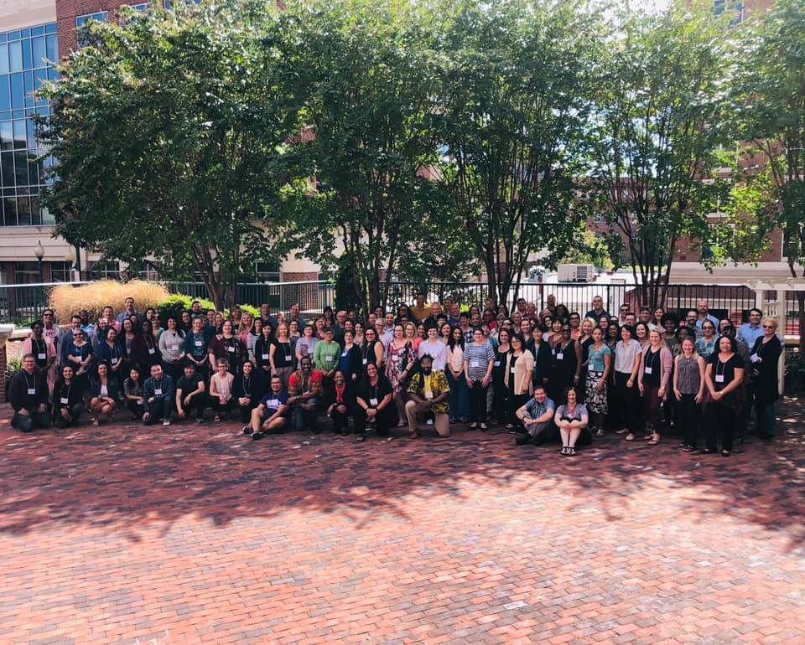

Monday, October 19, 2020
SCD and Board Meetings
EST
12:00pm – 5:30pm | Board Meeting
12:00pm-2:30pm | SCD Meeting
3:00 – 4:00pm | SCD & Board Joint Meeting
4:00 – 5:30pm | Goodbyes and wrap up

Monday, October 19, 2020
Pre-Conference Schedule
EST
11:00 am – 11:15 am | Pre-Conference Opening  Carmen Cruz, Psy.D.  Jason Hindman, Ph.D. - Host  Announcements:  Mentor program  Explanation of SCD processes  CE process
11:15 am – 12:00 pm | Identity as a New Training Coordinator/Director  Mark Sampson, Ph.D.  Charisse Williams, Ph.D.
 | Break
12:30 - 2:00 pm | Session 1 (1.5 CEs)  Training Coordinator/Director Timeline and Tips  Matt Zimmerman, Psy.D.  Maureen Lafferty, Ed.D.
 | Break
2:30 - 4:00 pm | Session 2 (1.5 CEs)  Managing the Internship Selection Process  Katie Werner, Ph.D.  Claytie Davis III, Ph.D., ABPP

Tuesday, October 20, 2020

EST
12pm – 2:30pm | Opening Session  - Introductions  - Welcome and State of ACCTA - Carmen Cruz  - Elections – Cecilia Sun  - CE announcements  - Treasurer’s Report – Di Sobel  - Annual Survey – Mollie Herman
 | Break
3pm – 5pm | Passages (2 CE’s)  Presenters: Laura Wright & Diane Hayashino

Wednesday, October 21, 2020

EST
11am – 12:30pm | Managing the Internship Selection Process: COVID  (1.5 CEs)  Terri Rhodes, Mary Mendoza-Newman, Mark Sampson
1pm – 2pm | Affinity Groups
2pm – 3:30pm | SCD Business Meeting and Conversation Hour  - SCD Elections Slate  - Voting for SCD committee members
 | Break
4pm – 5:30pm | Closing Session  - Elections  - Acknowledgments  - Helen Roehlke Award  - Passing of the Gavel  - Goodbyes from departing members  - Goodbye song

